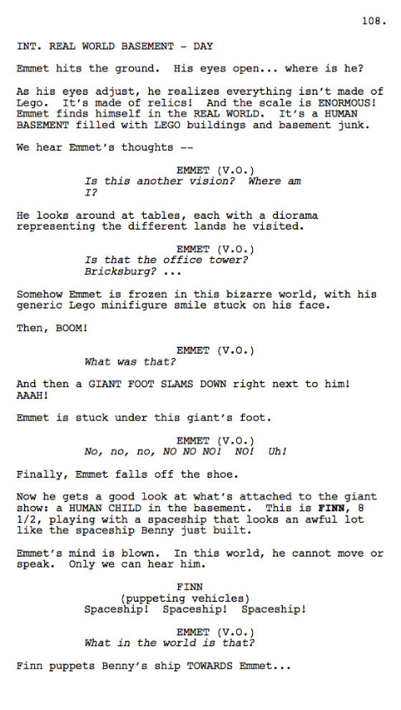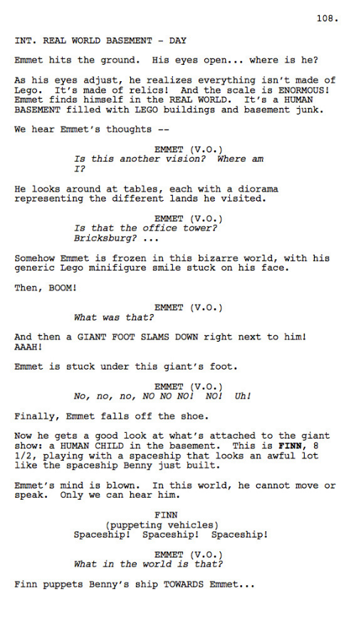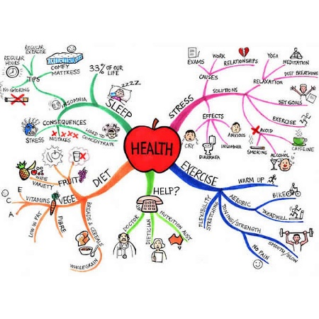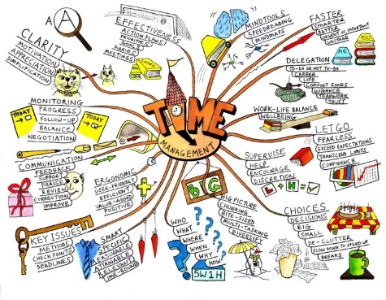

|  |  |  |
| --- | --- | --- |
| **C** | **Scripts: Key Vocab** | |
| **Audio** | | To do with sound |
| **Audio-visual** | | Combining sound and pictures (ie films) |
| **Formatting** | | How the words are presented on the page |
| **Indentation** | | Set in from one side of a page |
| **Dialogue** | | Talking between characters |

|  |  |  |
| --- | --- | --- |
| **A** | | **Scripts: Purpose** |
| 1 | Show the dialogue and delivery directions for actors | |
| 2 | Indicate sound effects and scene requirements for production crew | |
| 3 | Outline of a production for clients, advertisers or any other stakeholders | |

|  |  |  |
| --- | --- | --- |
| **B** | | **Scripts: Content** |
| 1 | **Dialogue** | |
| 2 | **Stage directions** | |
| 3 | **Sound effects** | |
| 4 | **Names and details of characters** | |
| 5 | **Music or ambient sound** | |
| 6 | **Location** | |
| 7 | **Camera shot** | |
| 8 | **Camera movement** | |

|  |  |  |
| --- | --- | --- |
| **D** | | **Mind maps: Content** |
| 1 | **Central *node* with main theme** | |
| 2 | ***Sub-nodes* with related *general* ideas** | |
| 3 | **Sub-sub-nodes with *specific* ideas** | |
| 4 | ***Links* between nodes** | |
| 5 | **Text to show ideas** | |
| 6 | Sometimes **Images** | |

|  |  |  |
| --- | --- | --- |
| **E** | | **Mind maps: Purpose** |
| 1 | Generate ideas | |
| 2 | Develop ideas | |
| 3 | Visually display how ideas might relate | |

|  |  |  |
| --- | --- | --- |
| **F** | **Mind maps: Key Vocab** | |
| **Node** | | An idea in a mind map |
| **Sub-node** | | A node which is further away from the central node (ie *Menu* is a sub-node of *Website*. *Info* is a sub-node of *Menu)* |
| **Link** | | A connection between nodes |
| **General** | | Relating to lots of things |
| **Specific** | | Relating to few things |

Name:

R081: Scripts and Mind Maps



|  |  |  |
| --- | --- | --- |
| **C** | **Scripts: Key Vocab** | |
| **Audio** | | To do with sound |
| **Audio-visual** | | Combining sound and pictures (ie films) |
| **Formatting** | | How the words are presented on the page |
| **Indentation** | | Set in from one side of a page |
| **Dialogue** | | Talking between characters |

|  |  |  |
| --- | --- | --- |
| **A** | | **Scripts: Purpose** |
| 1 | Show the dialogue and delivery directions for actors | |
| 2 | Indicate sound effects and scene requirements for production crew | |
| 3 | Outline of a production for clients, advertisers or any other stakeholders | |

|  |  |  |
| --- | --- | --- |
| **B** | | **Scripts: Content** |
| 1 | **Dialogue** | |
| 2 | **Stage directions** | |
| 3 | **Sound effects** | |
| 4 | **Names and details of characters** | |
| 5 | **Music or ambient sound** | |
| 6 | **Location** | |
| 7 | **Camera shot** | |
| 8 | **Camera movement** | |

|  |  |  |
| --- | --- | --- |
| **D** | | **Mind maps: Content** |
| 1 | **Central *node* with main theme** | |
| 2 | ***Sub-nodes* with related *general* ideas** | |
| 3 | **Sub-sub-nodes with *specific* ideas** | |
| 4 | ***Links* between nodes** | |
| 5 | **Text to show ideas** | |
| 6 | Sometimes **Images** | |

|  |  |  |
| --- | --- | --- |
| **E** | | **Mind maps: Purpose** |
| 1 | Generate ideas | |
| 2 | Develop ideas | |
| 3 | Visually display how ideas might relate | |

|  |  |  |
| --- | --- | --- |
| **F** | **Mind maps: Key Vocab** | |
| **Node** | | An idea in a mind map |
| **Sub-node** | | A node which is further away from the central node (ie *Menu* is a sub-node of *Website*. *Info* is a sub-node of *Menu)* |
| **Link** | | A connection between nodes |
| **General** | | Relating to lots of things |
| **Specific** | | Relating to few things |

Name:

R081: Scripts and Mind Maps